* [Retrieve everything from a table](https://pgexercises.com/questions/basic/selectall.html)

select * from cd.facilities;

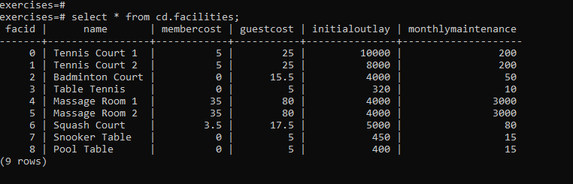

* [Retrieve specific columns from a table](https://pgexercises.com/questions/basic/selectspecific.html)

select name, membercost from cd.facilities;

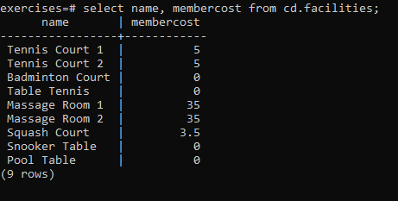

* [Control which rows are retrieved](https://pgexercises.com/questions/basic/where.html)

select * from cd.facilities where membercost > 0;

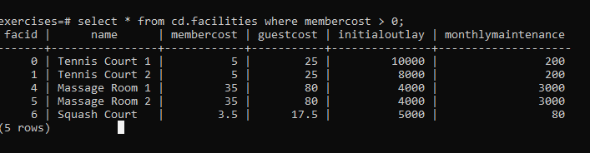

* [Control which rows are retrieved - part 2](https://pgexercises.com/questions/basic/where2.html)

**select** facid, name, membercost, monthlymaintenance

**from** cd.facilities

**where**

membercost > 0 **and**

(membercost < monthlymaintenance/50.0);

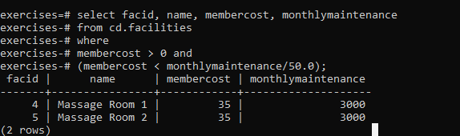

* [Basic string searches](https://pgexercises.com/questions/basic/where3.html)

**select** *

**from** cd.facilities

**where**

name **like** '%Tennis%';

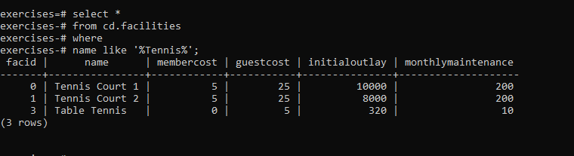

* [Matching against multiple possible values](https://pgexercises.com/questions/basic/where4.html)

select *

from cd.facilities

where

facid in (1,5);

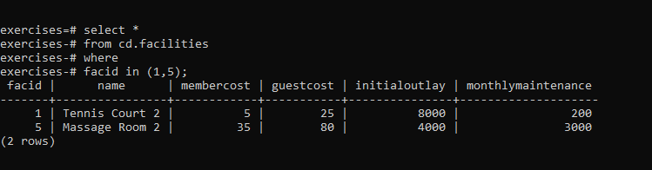

* [Classify results into buckets](https://pgexercises.com/questions/basic/classify.html)

**select** name,

**case** **when** (monthlymaintenance > 100) **then**

'expensive'

**else**

'cheap'

**end** **as** cost

**from** cd.facilities;

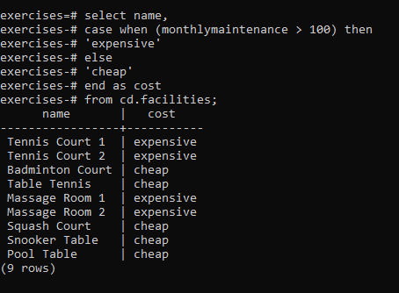

* [Working with dates](https://pgexercises.com/questions/basic/date.html)

**select** memid, surname, firstname, joindate

**from** cd.members

**where** joindate >= '2012-09-01';

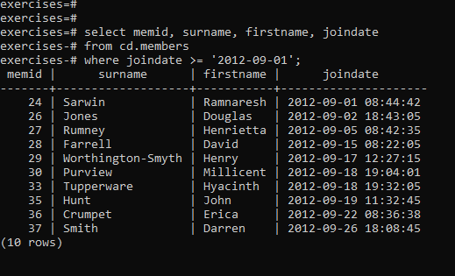

* [Removing duplicates, and ordering results](https://pgexercises.com/questions/basic/unique.html)

**select** **distinct** surname

**from** cd.members

**order** **by** surname

limit 10;

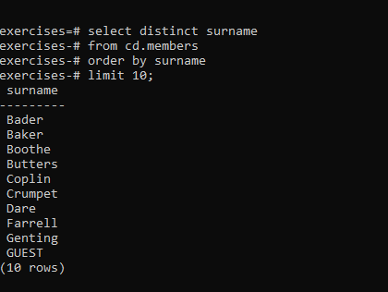

* [Combining results from multiple queries](https://pgexercises.com/questions/basic/union.html)

**select** surname

**from** cd.members

**union**

**select** name

**from** cd.facilities limit 5;

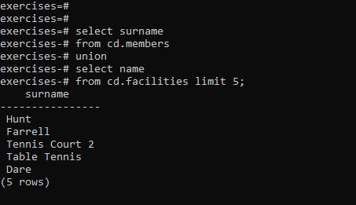

* [Simple aggregation](https://pgexercises.com/questions/basic/agg.html)

**select** max(joindate) **as** latest

**from** cd.members;

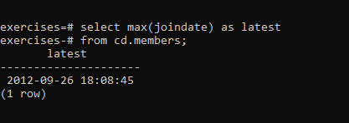

* [More aggregation](https://pgexercises.com/questions/basic/agg2.html)

**select** firstname, surname, joindate

**from** cd.members

**where** joindate =

(**select** max(joindate)

**from** cd.members);

